ARG Pre-proposal

1. Project Title: Assessment of Phytoremediation potential of grass species growing in Smart cities of Punjab: improvement using earthworm and biochar assistance
2. Project Duration: 36 months
3. Project Summary: Metal(loid) contamination of terrestrial ecosystems is a global concern. The metal(loid)s such as As, Cd, Cr, Co, Cu, Pb, Ni, etc. originate from different sources which include both natural as well as anthropogenic. But anthropogenic sources such as agrochemicals-based agriculture, contaminated irrigation sources, vehicular emissions, industrial inputs, solid waste dumping, aerial depositions from point and non-point sources etc. cause excessive increase in metal(loid)s concentrations in soils under different land uses. The situation of soil contamination in urban areas are under severe threat of metal(loid)s contamination due to multitude of contamination sources (such as solid waste dumping, industrial inputs, vehicular emission etc.). The excessive contamination of these soils pose serious ecological and human health risks. In Punjab also, the soils contamination is a significant problem in the big cities (Amritsar, Jalandhar and Ludhiana) selected under Smart City Project of government of India. In order to decontaminate these soils, sustainable, low cost and green remediation measures are required. In this regard, phytoremediation can as a possible solution. Phytoremediation is the technique of using growing those plant species on contaminated soils which an accumulate large quantities of these metal(loid)s. Traditionally, many food, fodder and ornamental crops have been analyzed for their metal(loid) accumulation potential. But, these crops require high nutrient inputs and considerable human care. After accumulation of large quantities of metal(loid)s these crops become unusable which can result in economic loss. Thus, for phytoremediation plant species which are low cost, fast growing, high in biomass and requiring least human care are required. In this regard, grasses can act as a sustainable choice. Grasses are ubiquitously present, have high growth rate, significant biomass and require negligible human care. Keeping this in view, the proposed study has been planned with the aim to identify native grass species growing in contaminated urban areas of Amritsar and Jalandhar having high metal(loid) accumulation potential. The study will further focus on enhancing the metal(loid)s accumulation potential of selected grass species using amendments such as biochar and earthworms.
4. Keywords: Phytoremediation; Grasses; Metal(loid)s; Smart Cities; Amendments
5. Objectives of the Project (in bullets):
- Monitoring of metal(loid) contaminated areas of Amritsar and Jalandhar (in the vicinity of industries, roadsides, solid waste dumpsites etc.) to collect soil and native grass samples.
- Analysis of metal(loid)s in soil and grass samples to identify the species having high phytoremediation potential.
- Evaluation of the potential of rice husk biochar and vermiremediation to enhance the phytoremediation capacity of selected grass species in two modes of laboratory experimentation i.e. separately and in combination.

6. Novelty & Significance:
- Novel Focus on Native Grasses - Traditional phytoremediation studies focused on food and fodder crops, but this research focuses on investigating native grass species for sustainable contamination remediation solutions.
- Addressing Critical Knowledge Gap - Punjab's contaminated soils lack comprehensive phytoremediation research, particularly for native grasses, creating urgent need for localized environmental solutions.
- Cost-Effective Green Technology - Grasses grow without nutritional supplements, offering unprecedented low-cost, sustainable alternative to expensive physical and chemical remediation methods.
- Strategic Urban Application - Targeting smart cities (Amritsar, Jalandhar and Ludhiana) addresses severe industrial contamination while supporting Punjab's economic development through green technology.
- Scalable Environmental Solution - Identifying high-performing native species enables widespread implementation across urban and rural contaminated sites, revolutionizing ecosystem restoration approaches.
7. Preliminary work done, if any: No preliminary work is done till now.
8. Research Methodology
The proposed research work would be carried out in following steps:
8.1. Collection of soils and grass species from contaminated areas: The metal(loid) accumulation potential of native grass species growing in contaminated sites of Amritsar and Jalandhar would be analyzed by carrying out monitoring studies in contaminate areas (roadsides, industrial areas, solid waste dumpsites etc.) in first part of the project. Fig. 1 presents the study area. Samples of grass plants growing in contaminated sites will be collected with soil samples of those contaminated areas.

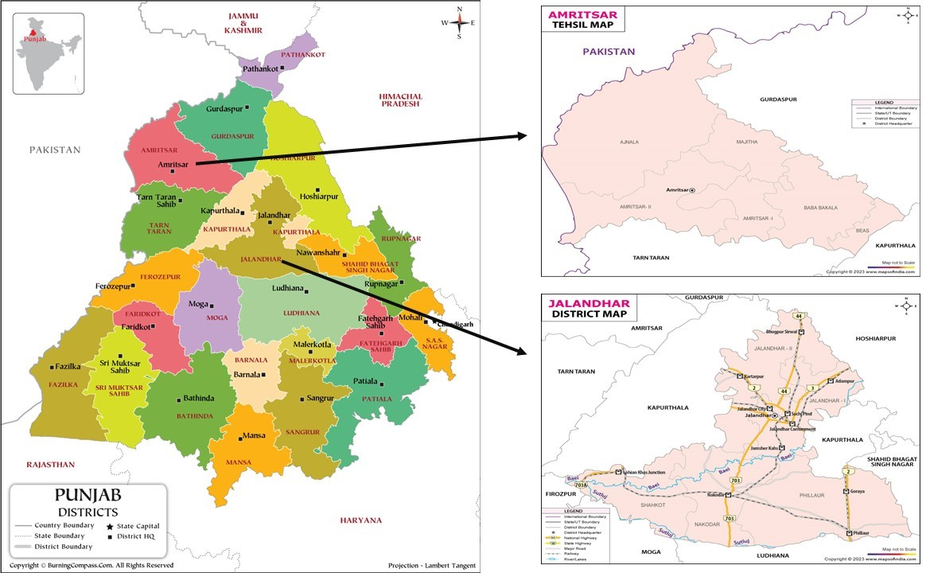
Fig. 1. Map to the study area (district Amritsar and Jalandhar)

8.2. Analysis of metal(loid) contents in soil and grass samples: The collected soil and grass plants samples would be acid digested in Laboratory fume hood using aqua regia ((HNO₃: HCl in 3:1 ratio) and triacid mixture (HNO₃:H₂SO₄:HClO₄ in 5:1:1 ratio) by method of Allen et al. (1986). Different metal(loid)s would be analyzed in soil and grass samples using techniques such as ICPMS and AAS and grass species having maximum metal(loid) accumulation potential would be determined by using equations such as Bioaccumulation factor (BCF) and Translocation factor (TF).
Bioaccumulation factor (BAF):
Bioaccumulation Factor (BAF) is a ratio of metal(loid) concentration in plant tissue to soil (Ali et al., 2013):
BAF = C_{plant tissue} /C_{soil} (1)
where C_{plant tissue} and C_{soil} are the concentrations of metal(loid) in plant tissues (roots, stems and leaves) and soil, respectively, on a dry weight basis.
Translocation factor (TF):
Translocation Factor (TF) is the ability of a plant to move the accumulated heavy metal from roots to above ground tissues (stems, leaves and inflorescences) (Ali et al., 2013):
TF = C_{stem/leaves}/C_{roots} (2)
TF = C_{leaves}/C_{stem} (3)
where C_{leaves}, C_{stem} and C_{roots} are the concentrations of the metal(loid) in plant leaves, stem and roots, respectively on a dry weight basis.
8.3. Biochar formation: Simple biochar would be formed by pyrolysis of organic wastes (mainly rice husk) for using in the study.
8.4. Pot experimentation setup: In first set up, the three grass species determined in the preliminary study having maximum metal(loid) accumulation potential would be grown in pots/fields having metal(loid) (As, Cd, Cr, Ni and Pb salts at different concentrations for different periods of times) spiked soils for determination of their phytoremediation potential. In second setup, pots having metal(loid) spiked soils would be amended with biochar (at varying concentrations) and earthworms (Eisenia fetida) in separate treatments for assessment of their remediation potential. The third setup would include grass plants grown in pots/fields having metal(loid) spiked soils with amendment of biochar (at varying concentrations) and earthworms to determine their potential to enhance phytoremediation of grass species.
8.5. Metal(loid) Amelioration potential analysis grasses with amendments: Metal(loid) contents would be analyzed in soils pre and post treatments with grasses+biochar, grasses+earthworm and grasses+biochar+earthworm determine the remediation potential. Metal(loid) contents would be analyzed in soils and plant parts at different times for 15-30 days to analyze the phytoremediation potential of grasses under different treatments.

9. GANT/PERT Chart for the project with timelines for the proposed duration
First financial year | 1 | 2 | 3 | 4 | 5 | 6 | 7 | 8 | 9 | 10 | 11 | 12
Purchase of equipment, chemicals and glassware.
Appointment of Staff (JRF & TA)
Identification of contaminated sites for sampling in the two cities
Collection of soil and grass samples from the contaminated sites
Analysis of soil for physico-chemical characteristics and metal(loid)s
Estimation of metal(loid)s in grass samples and identification of best performing species
Second financial year
Standardization of protocol for rice husk biochar for determining optimal conditions for its application in metal(loid) removal.
Carrying out pot based experimentation to analyze the maximum metal(loid) accumulation potential of selected grass species alone and in combination of biochar and earthworms.
Third financial year
Continuation of the pot-based experimentation
Compilation of data
Publications of research articles
Preparation of final report

10. Technology Readiness Level (TRL) of the project:

11. Expertise of PI & Co-PI:
Principal Investigator: Dr. Sandip Singh
Papers:
Bhatti SS, Kumar V, Sambyal V, Singh J, Nagpal AK (2018). Comparative analysis of tissue compartmentalized heavy metal uptake by common forage crop: A field experiment. Catena, 160:185-193. DOI: 10.1016/j.catena.2017.09.015.
Kaur R, Bhatti SS, Singh S, Singh J, Singh S (2018). Phytoremediation of heavy metals using cotton plant: A field analysis. Bulletin of Environmental Contamination and Toxicology, 101(5):637-643. DOI: 10.1007/s00128-018-2472-8.
Dhaliwal SS, Taneja PK, Singh J, Bhatti SS, Singh R (2020). Cadmium accumulation potential of Brassica species grown in metal spiked loamy sand soil. Soil and Sediment Contamination: An International Journal, 29(6):638–649. https://doi.org/10.1080/15320383.2020.1758031.
Bhatti SS, Bhat SA, Singh J (2020). Aquatic plants as effective phytoremediators of heavy metals. In Contaminants and Clean Technologies (pp. 189-199). CRC Press.
Bhatti SS*, Bhatia A, Bhagat G, Singh S, Dhaliwal SS, Sharma V, Verma V, Yin R, Singh J (2024). PAHs in Terrestrial Environment and their Phytoremediation. In Bioremediation for Sustainable Environmental Cleanup (pp. 67-85). CRC Press. (pp. 67-85). CRC Press.
Singh J, Bhatti SS, Singh S, Balasubramani R (2023). Editorial: Vermiremediation in contaminated soils: An approach for soil stabilization. Frontiers in Environmental Science. DOI 10.3389/fenvs.2023.1137463.

Co-Principal Investigator: Dr. Jaswinder Singh
Papers:
Sartaj Ahmad Bhat, Jaswinder Singh, Adarsh Pal Vig (2014). Genotoxic assessment and optimization of pressmud with the help of exotic earthworm Eisenia fetida Environment Science & Pollution Research. 21:8112–8123
Joshi R, Singh J, Vig AP (2015). Vermicompost as an effective organic fertilizer and biocontrol agent: effect on growth, yield and quality of plants Reviews in Environmental Science and Biotechnology14: 137-159
Singh J, Sharnpreet Singh, Adarsh Pal Vig (2015). Extraction of earthworm from soil by different sampling methods: a review. Environment Development & Sustainability,18:1521-1539.
Jaswinder Singh, Nico Eisenhauer, Martin Schadler, Simone Cesarz, 2021. Earthworm gut passage reinforces land-use effects on soil microbial communities across climate treatments. Applied Soil Ecology, 164 (2021) 103919.
Helen R. P. Phillips et al., 2019. Global distribution of earthworm diversity. Science. 366: 480-485.

Co-Principal Investigator: Dr. Ashok Kumar
Papers:
Kumar, A., Chhillar, R. K., & Gautam, R. C. (2011). Nutrient requirement ofwinter maize (Zea mays)-based intercropping systems. The Indian Journal of Agricultural Sciences, 76(5).
Kumar, A., Soodan, A.S (2013) Taxonomic description of Elytrophorus spicatus (Willd.) A campus (Poaceae: Arundinoideae, Arundineae, from the shiwaliks of Northern India. Botany Research International, 6(3): 71-73.
Kumar, A., Sharma, S., Kaur, R., & Soodan, A. S. (2015). A Study of Punjab Grasses as Indicators of Environmental Change. Botany Research International 8 (2): 41-46
Soodan, A.S, Sharma, S. Kumar, A. Kaur, R. (2020). Morpho functional diversity of diaspores of some range grasses of Punjab (India). Proceedings of 23 international Grassland Congress (Sustainable use of Grassland Resources for Forage Production, Biodiversity and Environmental Protection) took place in New Delhi, India from November 20 to November 24, 2015.
Thakur, A., Kumari, R., Kumar, A., & Chaudhary, A. (2024). Quantitative ethnobotanical study of medicinal plants used by native people of selected areas of Chhota Bhangal, Himachal Pradesh. Ethnobotany Research and Applications, 28, 1-34.

12. Details of collaboration:
Name &  Affiliation | Role in the  project | Institute | Budget  requirement | Justification
Dr. Jaswinder Singh | (i) Collection of soil and grass samples  (ii) Analysis of earthworm assisted remediation  (iii) Analysis of metal(loid) contents in soil and grass samples | Khalsa College, Amritsar, Punjab | NA | Renowned Expert in Earthworm identification and vermiremediation
Dr. Ashok Kumar | (i) Identification of grass plant species  (ii) Analysis of key plant parameters involved in phytoremediation  (iii) Assistance in pot based experimental study | Central University of Jammu, Jammu | NA | Expert in grass taxonomy and diversity of north India

13. Expected outcome of the proposal:

This research project has been designed to identify the best performing native grass species of Punjab for phytoremediation of metal(loid) contaminated soils of urban areas which are contaminated due to various anthropogenic activities. The research work also focuses on performance of these grass species in combination with physical (biochar) and biological (earthworm) amendments in order to enhance their phytoremediation potential. The research data from this project can provide valuable information about the possible metal(loid) hyper-accumulator native grass species which can be grown in contaminated soils of Punjab and other parts of India for their decontamination. Therefore, this project can provide a low cost, low maintenance, sustainable and green solution for our soil pollution with metal(loid)s and the results can be beneficial for following departments of the state:
- Pollution control
- Urban development
- Health
- Agriculture
- Academics and Research Institutes
- For general public awareness

14. Total Budget proposed for the project:
(a) Budget for PI (Recurring + Nonrecurring): Rs. 44,02,400/-
(b) Budget for Co-PI (Recurring + Nonrecurring): NA

